Experiment 1.1

Student Name: Aradhya Sharma UID: 25MCC20042
Branch: MCA (CCD) Section/Group: 25MCC-101A
Semester: 2 Date of Performance: 10 JAN 2026

Subject Name: Technical training Subject Code: 25CAP-652

Experiment 1.1: Database System Implementation using DDL, DML, and DCL Commands

- AIM
To design and implement a sample database system using DDL, DML, and DCL commands, ensuring data integrity through constraints and providing secure, read-only access using role-based privileges.

- OBJECTIVE
- To create database tables using DDL commands with appropriate constraints
- To insert, update, and delete records using DML commands
- To modify database schema using ALTER statements
- To implement role-based access control using DCL commands

SOFTWARE REQUIREMENTS
To perform this experiment, the following software is required:
- Operating System
  - Windows 10 / 11, Linux, or macOS
- Database Management System (DBMS)
  - PostgreSQL (version 12 or higher)
- SQL Client / Interface
  - pgAdmin 4 (for PostgreSQL)
OR
  - Command Line Interface (psql)

- PRACTICAL/ EXPERIMENT STEPS:
- Design the database schema for Department, Employee and Project tables.
- Create tables using appropriate constraints.
- Insert sample records into tables.
- Perform update and delete operations.
- Retrieve data using SELECT queries.
- Create a role and grant/remove privileges.
- Alter and Drop database objects.
- PROCEDURE FOR EXPERIMENT

1. Table Creation (DDL Commands)

CREATE TABLE department (

id INT PRIMARY KEY,

name VARCHAR(50) NOT NULL UNIQUE,

description VARCHAR(100),

created_at DATE DEFAULT CURRENT_DATE

);

CREATE TABLE project (

id INT PRIMARY KEY,

name VARCHAR(50) NOT NULL,

due_date DATE NOT NULL,

budget DECIMAL(10,2),

status VARCHAR(20) CHECK (status IN ('Planned', 'Ongoing', 'Completed')),

dept_id INT,

FOREIGN KEY (dept_id) REFERENCES department(id)

);

CREATE TABLE employee (

id INT PRIMARY KEY,

name VARCHAR(50) NOT NULL,

age INT CHECK (age >= 18),

salary DECIMAL(10,2),

mobile VARCHAR(20) UNIQUE NOT NULL,

email VARCHAR(50) UNIQUE,

designation VARCHAR(50),

hire_date DATE DEFAULT CURRENT_DATE,

dept_id INT,

FOREIGN KEY (dept_id) REFERENCES department(id)

);

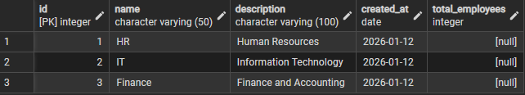

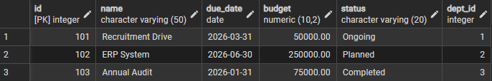

2. Data Manipulation (DML Commands)

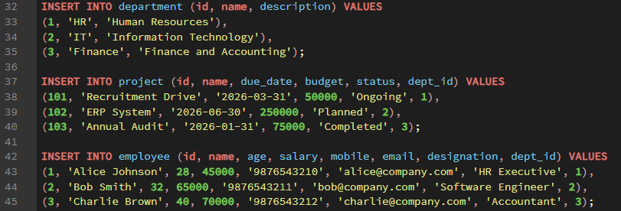

DELETE FROM employee

WHERE id = 1;

UPDATE employee

SET name = 'Mary'

WHERE id = 2;

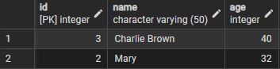

3. Schema Modification (DDL Command)

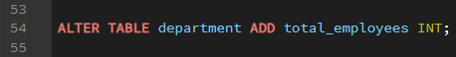
- Access Control (DCL Commands)

CREATE ROLE reporting_user

LOGIN

PASSWORD 'report123';

GRANT SELECT ON department TO reporting_user;

GRANT SELECT ON project TO reporting_user;

GRANT SELECT ON employee TO reporting_user;

GRANT USAGE ON SCHEMA public TO reporting_user;

REVOKE INSERT, UPDATE, DELETE ON department FROM reporting_user;

REVOKE INSERT, UPDATE, DELETE ON employee FROM reporting_user;

REVOKE INSERT, UPDATE, DELETE ON project FROM reporting_user;

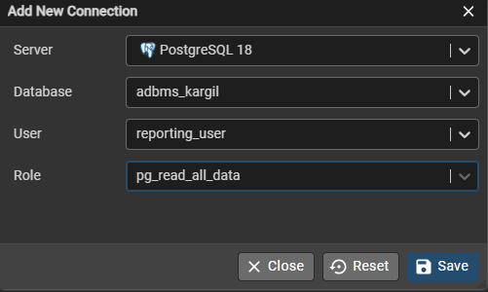

- LEARNING OUTCOMES
- Understood the use of DDL commands to create and modify database schemas
- Gained experience with DML commands for inserting, updating, and deleting data
- Learned to enforce data integrity using primary key, foreign key, check, and unique constraints
- Implemented role-based security using DCL commands
- Ensured secure, read-only access for authorized users

